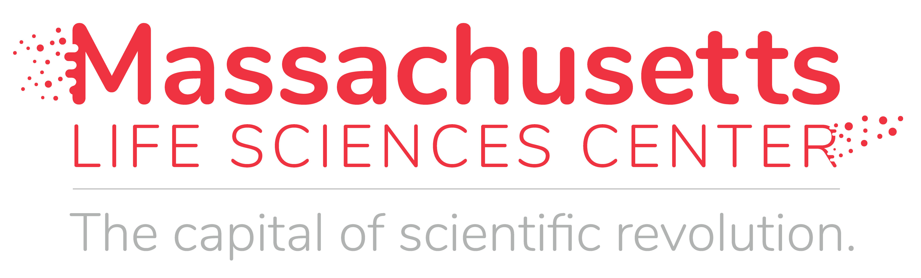
STEM Equipment and Professional Development Program
Annual Report for Curriculum Providers
Grant Recipient:
Primary Contact
Name:
Email:
Phone:
Award Amount:
Reporting Period:

- Briefly explain how the equipment purchased and training provided supported the implementation of curriculum.

- If applicable, describe any industry partners that were involved in the development or implementation of the curriculum.

- What programming changes, if any, are being made based on what you have learned this year?

- Please describe any outcomes from teacher professional development opportunities made possible with this grant.

- Have you identified further work with the districts/schools awarded through this grant? Please explain.

- How will the implementation of this curriculum at these schools inform your work with additional districts/schools moving forward?

- Please share any other information or comments related to this grant that will help our life sciences community understand the impact of this program.

Metrics:
Schools supported through grant:
School | District (if applicable) | # Students in classes | # Teachers receiving PD

Student Outcomes

To the extent possible, please respond to the following and only include data from the most recent academic year):
High School Student Outcomes (if applicable) | Students/Grads
Number of students placed in life sciences internships while enrolled in the program:
Number of students placed in life sciences jobs or internships after graduating the program:
Number of graduates majoring in life sciences either at a 2- or 4-year college:
Number of graduates who plan to continue education or work in Massachusetts:
If applicable, number of certifications students achieved through the program:

Middle School Student Outcomes (if applicable) | Students/Grads
Number of students who benefitted from this grant who entered high school (9th grade):
Number of students who plan to take advanced life science courses in high school:
Number of field trips to life science companies:
Number of career events at school focused on life sciences (i.e. speakers, special programs, etc.):

Please indicate any other funding that was leveraged for implementation of this grant.
Funding Source | Amount | Schools Receiving Funding

Please attach any additional metrics that your organization tracks related to the grant.

